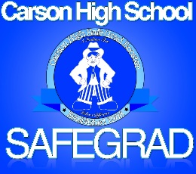
CHSGB
President - Karri Couste
Vice President – Jodi Swirczek
Secretary – Deanna Fine
Treasurer – Darla Dodge

Carson High Safe Grad Booster
Safe Grad - A Tradition That Makes A Difference

Agenda
Tuesday, May 10, 2016
6:00pm-7:30pm
Q’s BBQ

- Call to Order

- Approval of Minutes from April 10, 2016 Action

- Treasurer’s report Action

- New News

  - Election of Officers Action

- Committee updates

  - Busses
  - Food
  - Volunteers
  - Registration
  - Decorations

- Old news
  - Nevada Appeal

- Next Meeting: Tuesday, June 14, 2016 @ 6:00pm

- Adjourn

